Risk Assessment
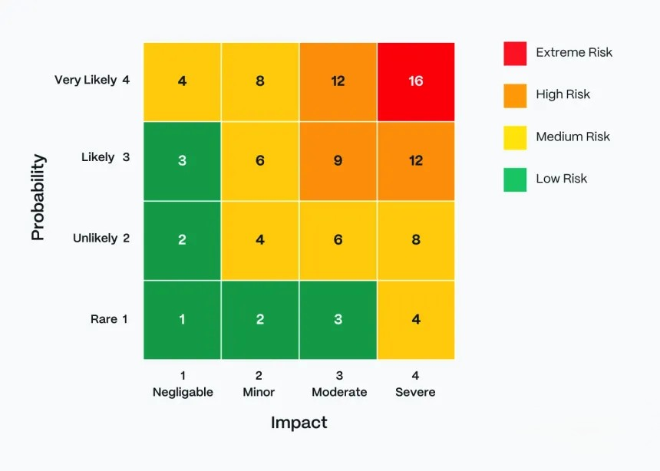
Hazards Identified | Who might be harmed & how | Severity | Probability | Score | Control Measures Required
Data breach / hacking | All users – personal data (email, name) could be exposed | 4 | 4 | 16 | Use HTTPS encryption, secure servers, regular updates
Weak passwords | Users – accounts could be hacked | 3 | 3 | 9 | Enforce strong passwords and guidance
Inappropriate messaging | Students/users – risk of bullying | 3 | 3 | 9 | Admin monitoring, behaviour rules
Inappropriate content uploads | All users – exposure to harmful content | 3 | 2 | 6 | All posts are moderated before publishing
Delay in moderation | All users – harmful content not removed quickly | 3 | 2 | 6 | Active moderators and review system
Misinformation | Students – incorrect learning | 2 | 3 | 6 | Content checked by teachers/admins
Cyber attacks | All users – data loss or downtime | 4 | 3 | 12 | Secure hosting, backups
Privacy risks | All users – data visible publicly | 4 | 3 | 12 | Privacy settings, minimal data sharing
Loss of coursework / data | Students – lose assignments | 4 | 2 | 8 | Auto-save, cloud backups, version history
Unauthorized access to classes | All users – Exposed to harmful material or teaching material stolen | 4 | 1 | 4 | Invite-only access, access codes, teacher approval

